My Capstone Project

I want to create an escape room where the player has to use clues, accomplish tasks and eventually find the key to get out.

Students will be presented with a scenario where they inherit a home and when they get there and enter a room they get locked in and must find a way out.

The room will be structured like this and I will model everything in blender except some furniture which is readily available online.

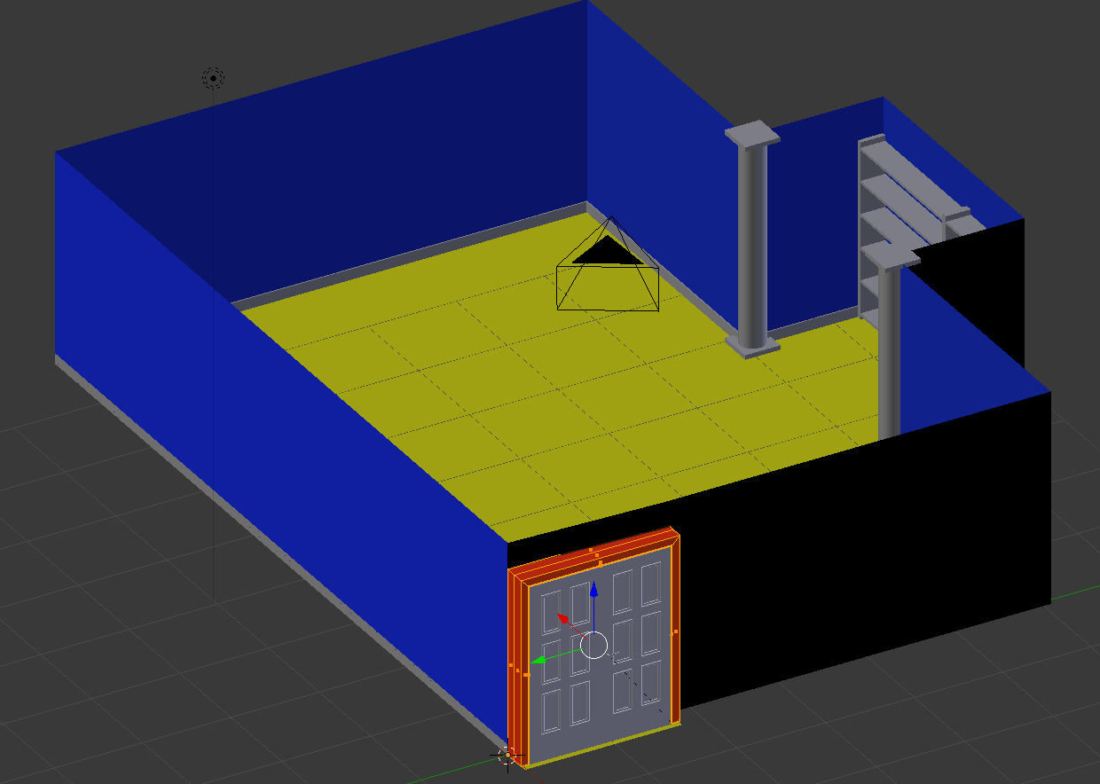

There will be a series of items, all related that the player must find to reach the ultimate goal.

Ideas/features for clues:

* a code on the back of a picture
* a monitor that when turned on a video clue is played
* Find a marble that when dropped in a device rolls through a tube and drops in an encased hole that triggers a door to open
* A safe that opens with a keypad combination
* Something that makes the player shrink and allows them to fit through a hole of some sort an find the key.
* A book that moves on the bookshelf that opens a port to reveal a clue
* A clue written under something that can only be seen if they bend down and look up.
* Spatial whispering in each ear just to creep them out.
* Fairly dark atmosphere with a chandelier

Marble ramps but not as bright

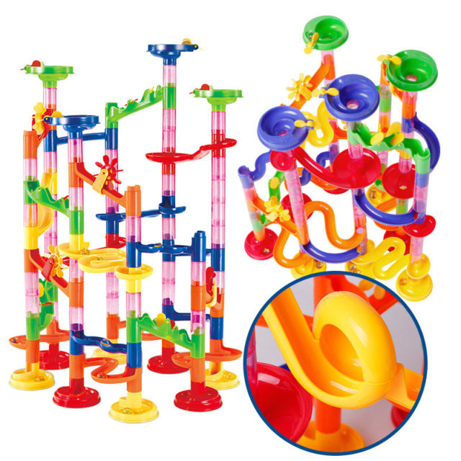

Digital safe which is hidden behind a painting

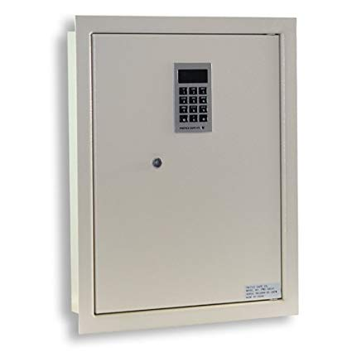

**VR Escape Room**

* I collaborated with my daughter on the mechanics of the escape room and came up with several ideas.
* The player will enter the room and it is creepy and dark inside with a dim chandelier. Inside the room is a flashlight. Soon after starting the game the chandelier blinks several times then goes out. The only way to see is with the flashlight and a small meter will be in the corner showing the percentage of battery is left. The game is over when either the player gets out or the batteries run down.
* The ultimate goal is to find the key to the door in the room. The key is hidden in a dollhouse sitting on a table in the room.
* To get the key, the player must get a device out of a hidden safe in the wall. The combination to the safe is found throughout the room. Through special whispers the player can only hear when close to an area of the room and a video that plays on an old black and white tv and vcr.
* The tape for the vrc is inside a locked drawer in a desk. The is a rube Goldberg type device on the desk that opens the drawer when a marble is dropped in a tube and it rolls into the desk.
* The marble is in a bowl of marbles on the bookshelf.
* The VRC doesn’t have power. The player will have to find the circuit panel and unlock it. The key to unlock it is under a book on the bookshelf.
* To get into the dollhouse and find the room key, the player needs to press the button on the device in the safe and the player shrinks down into the dollhouse. While in the dollhouse, the player goes upstairs and opens a drawer next to the bed and finds the key. They hit the button again and they are in the room again and can unlock the door and escape.

Achievements-

Fundamentals

1. Scale – Player shrinks and grows (100)
2. Lighting – Moving objects have real time lighting (100)
3. Locomotion – Teleporting system to move around (100)
4. Physics – The ball puzzle on the desk (100)
5. Video Player – VCR and TV (100)

Completeness

1. Diegetic UI – there are almost no instructions. Once they are in the room they will depend on logic and clues to solve the game (250)
2. 3d modeling – Almost everything in the scene I create with blender. The models will be in the assets folder (250)
3. Photogrammetry – I will use photogrammetry to create the VCR (250)

Challenges

1. User testing – I am a middle school teacher with 2 Oculus Rifts in my classroom. This will be extensively tested with lots of data (500)